Mohammed Raza Syed

STAT 5350/7110

Assignment 4

Q1)

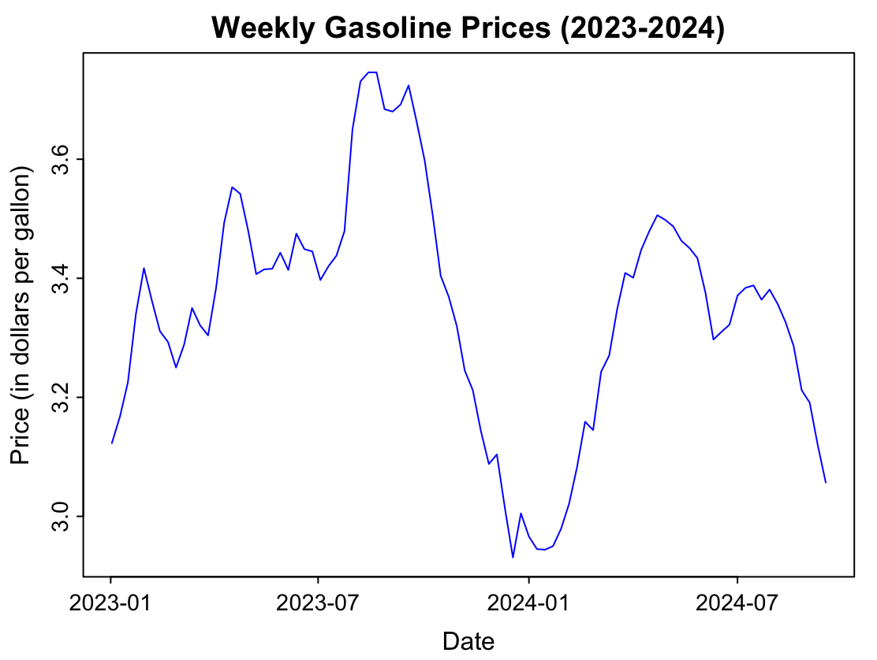

This time series appears to be stationary with mean of 3.34 and variance of 0.039. We do not see any great trends or seasonality patterns overall in the data and hence can conclude this time series is stationary in nature for the given period of 2023 – 2024.

Also for plotting this graph we had to use lubridate library in order for the x-axis label to be actual weeks instead of number of weeks.

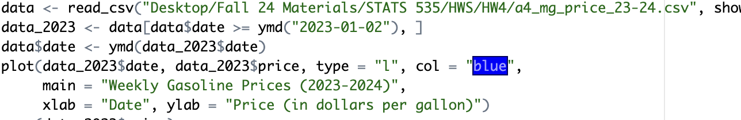

Q2)

Based on the **ACF and PACF** plots, an **AR(2) model** is appropriate for the weekly gasoline prices data. The PACF shows significant spikes at lags 1 and 2, with a cutoff after the second lag, while the ACF exhibits a gradual decay—patterns consistent with an AR(2) process.

To confirm, we compared BIC values across multiple ARMA models. The **AR(2) model (p=2, q=0)** had the lowest BIC value, indicating the best fit. Thus, both the ACF/PACF patterns and the BIC criterion support the choice of an AR(2) model for this dataset.

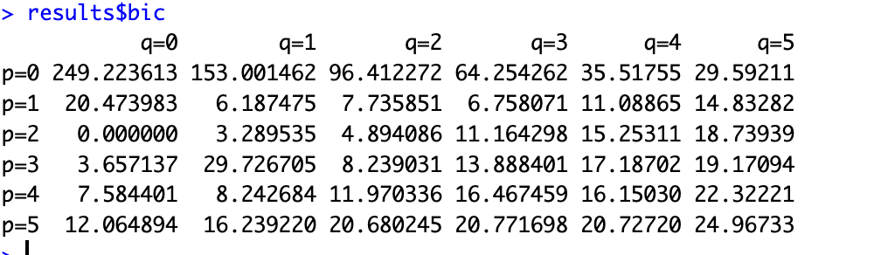

Q3

To fit an **AR(2) model** for the weekly gasoline prices data, we used **maximum likelihood estimation (MLE)** and compared the results to those from **least squares (LS) regression**.

The MLE results showed an **AR(1) coefficient (ar1)** of 1.4473 (SE = 0.0912), an **AR(2) coefficient (ar2)** of -0.4967 (SE = 0.0920), and an **intercept** of 3.2916 (SE = 0.0933). For LS regression, the **AR(1) coefficient** was estimated at 1.4536 (SE = 0.0947), the **AR(2) coefficient** at -0.5026 (SE = 0.0947), and the **intercept** at 0.1630 (SE = 0.0870).

While the AR coefficients are quite similar between MLE and LS methods, there is a notable difference in the intercept values. This discrepancy arises because MLE estimates the intercept as the mean level within the AR(2) model, while LS regression calculates it as a general constant term.

The ARIMA model has a very slightly lower standard error on residuals of 0.002146 compared to the dynamic linear model's 0.00224, showing that both models fit the data very closely.

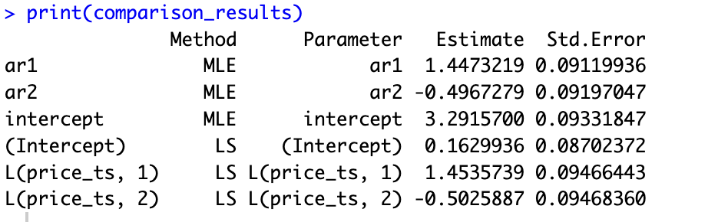

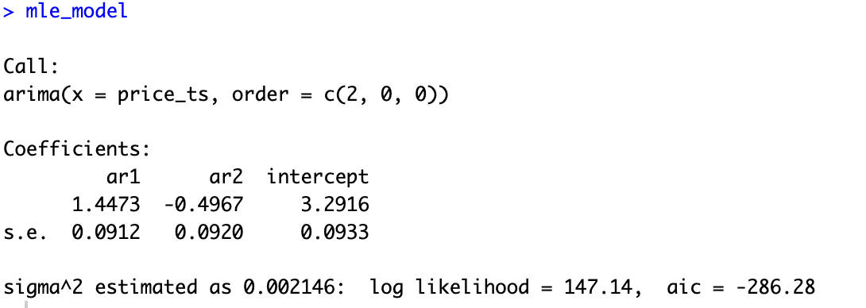

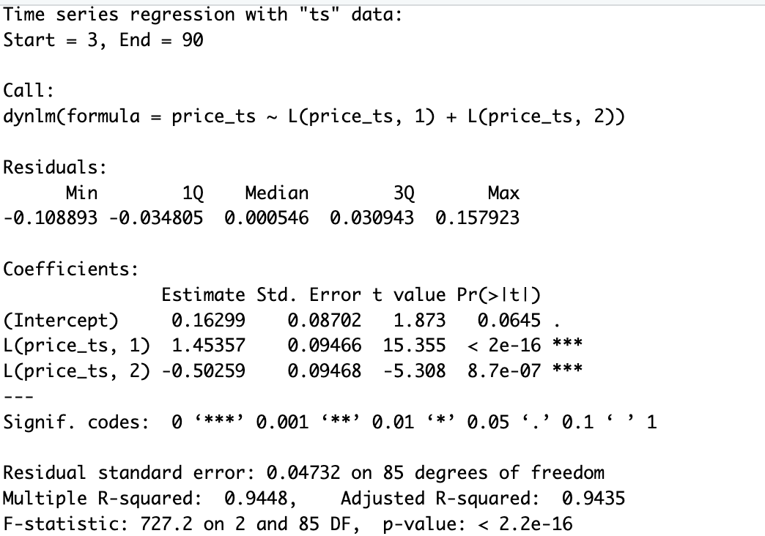

Q4)

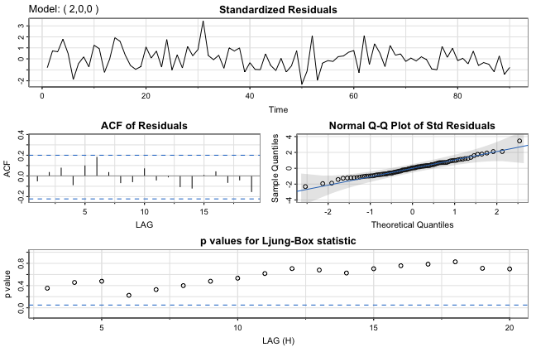

The **SARIMA diagnostics** for the fitted AR(2) model show that the residuals appear mostly random and uncorrelated, as indicated by the **ACF of residuals** with no significant spikes. The **Q-Q plot** suggests that the residuals are approximately normally distributed, aligning with the assumption of Gaussian noise. The **Ljung-Box test p-values** remain mostly above the 0.05 threshold, indicating that the residuals are likely uncorrelated and resemble white noise. Overall, the SARIMA diagnostics do not indicate any major inadequacies with the AR(2) model.

The ACF of residuals does not seem to cross the outer bonds on either side. It only reaches maximum autocorrelation at lag 6 but do not cross outer bounds.

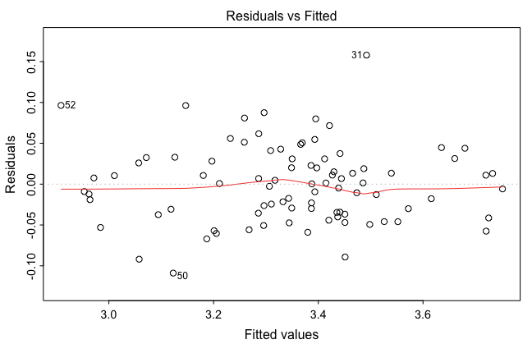

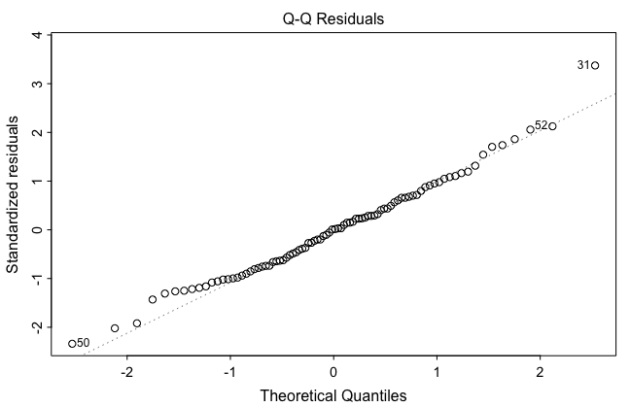

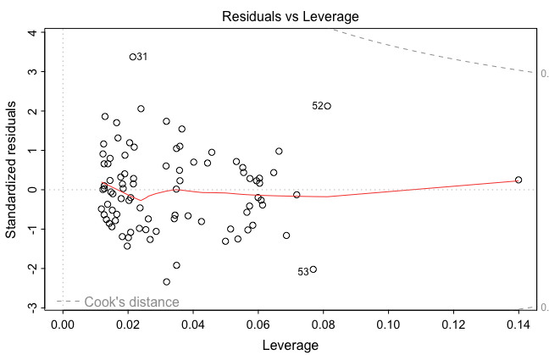



The **regression diagnostics** from the dynlm fit show similar results. The **Residuals vs. Fitted** plot indicates no clear patterns, suggesting that the model captures the main structure of the data without major bias. The **Q-Q plot** aligns well with the 45-degree line, further supporting the normality of residuals. The **Scale-Location plot** shows no significant trend in variance, implying homoscedasticity. Finally, the **Residuals vs. Leverage plot** reveals no outliers with high leverage, suggesting that no single point unduly influences the model. In summary, both SARIMA and regression diagnostics indicate that the AR(2) model fits the data adequately without significant issues.

Q5)

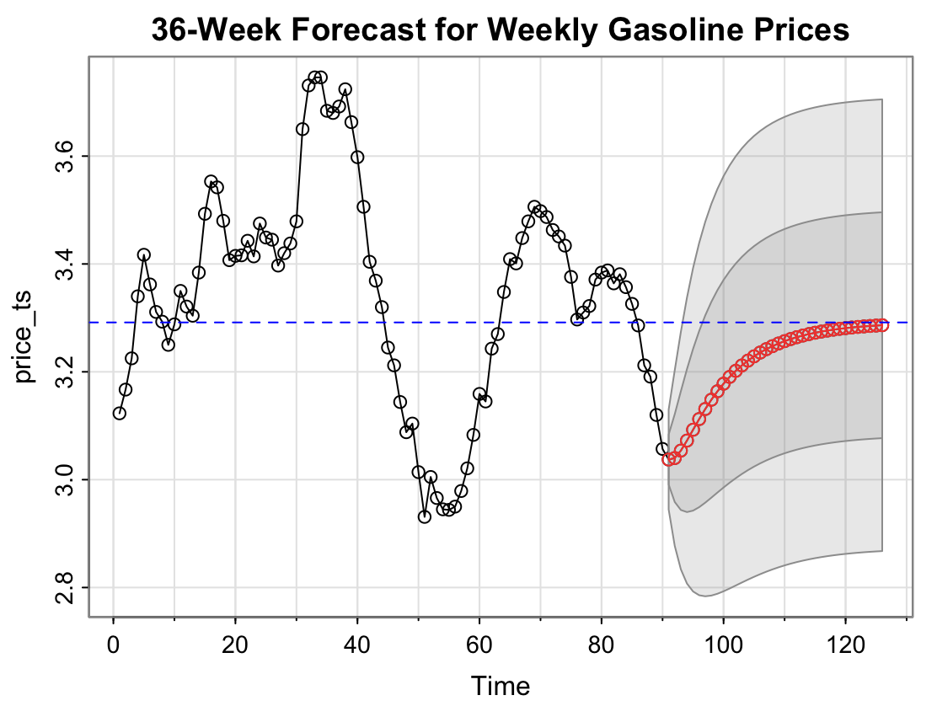

For the next 36-week forecast using the fitted AR(2) model, I applied **sarima.for** to generate forecasted values and their confidence intervals, visually displayed in a plot. The shaded regions represent one and two standard error intervals around the forecasts.

To summarize each weekly forecast, I extracted the forecasted values and standard errors and organized them into a data frame.

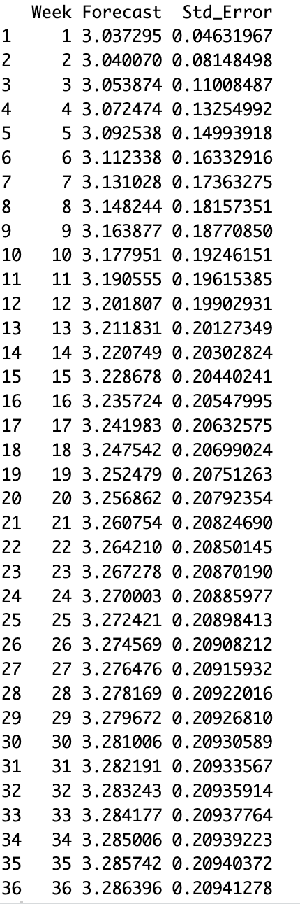

Q6)

mean_price <- mean(price_ts)

print(mean_price)

t_test <- t.test(price_ts, mu = 0)

print(t_test)

ar_model <- sarima(price_ts, p = 2, d = 0, q = 0,details=FALSE)

phi_1 <- ar_model$fit$coef["ar1"]

phi_2 <- ar_model$fit$coef["ar2"]

mu <- ar_model$fit$coef["xmean"]

price_ts

X_n <- tail(price_ts, 1)

X_n_minus_1 <- tail(price_ts, 2)[1]

intercept <- mu*(1-phi_1-phi_2)

intercept

X_n_plus_1 <- intercept + phi_1 * X_n + phi_2 * X_n_minus_1

X_n_plus_2 <- intercept + phi_1 * X_n_plus_1 + phi_2 * X_n

X_n_plus_3 <- intercept + phi_1 * X_n_plus_2 + phi_2 * X_n_plus_1

forecast_values <- c(X_n_plus_1, X_n_plus_2, X_n_plus_3) #

names(forecast_values) <- c("2024-09-23", "2024-09-30", "2024-10-07")

print(forecast_values)

forecast_values_auto <- forecast_results$pred[1:3]

print(forecast_values_auto)

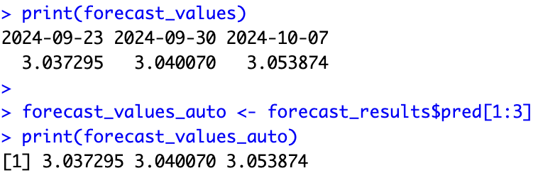

To manually reproduce the forecasts for the first three weeks (2024-09-23, 2024-09-30, and 2024-10-07), I used the AR(2) model’s coefficients and mean level obtained from the **sarima** function. First, I calculated an intercept based on the mean level, which served as a baseline for the forecasts.

Using this intercept and the AR coefficients, I computed each forecast iteratively. For each week, I used the previous values (observed or forecasted) to calculate the next forecast. The manually calculated forecasts closely matched the automatic predictions generated by **sarima.for**, confirming that the function follows an iterative approach with the AR(2) model structure to compute each forecast step. This process validated that **sarima.for** uses the AR parameters effectively to produce accurate forecasts.

Q7)

ar_model

sigma2 <- ar_model$fit$sigma2

sigma2

sigma <- sqrt(sigma2)

sigma

var_forecast_1 <- sigma2

se_forecast_1 <- sqrt(var_forecast_1)

var_forecast_2 <- sigma2 * (1 + phi_1^2)

se_forecast_2 <- sqrt(var_forecast_2)

var_forecast_3 <- sigma2 * (1 + phi_1^2 + (phi_1^2 + phi_2)^2)

se_forecast_3 <- sqrt(var_forecast_3)

standard_errors <- c(se_forecast_1, se_forecast_2, se_forecast_3)

names(standard_errors) <- c("2024-09-23", "2024-09-30", "2024-10-07")

print(standard_errors)

forecast_se_auto <- forecast_results$se[1:3]

print(forecast_se_auto)

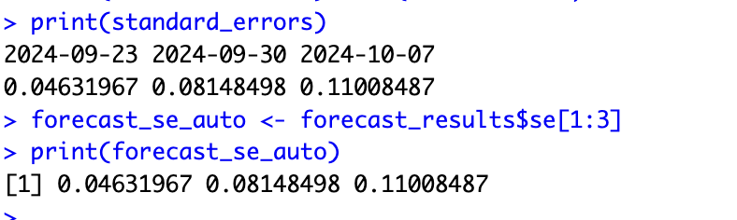

To calculate the standard errors for the forecasts for the first three weeks (2024-09-23, 2024-09-30, and 2024-10-07), I used the AR(2) model's estimated residual variance and autoregressive coefficients. For each step, I derived the forecast variance by incorporating the propagated error from previous forecasts, which accumulates over time.These manually calculated standard errors closely matched the automatic results from **sarima.for**, confirming that the function accounts for accumulated forecast uncertainty in each step.

Below is the working:  
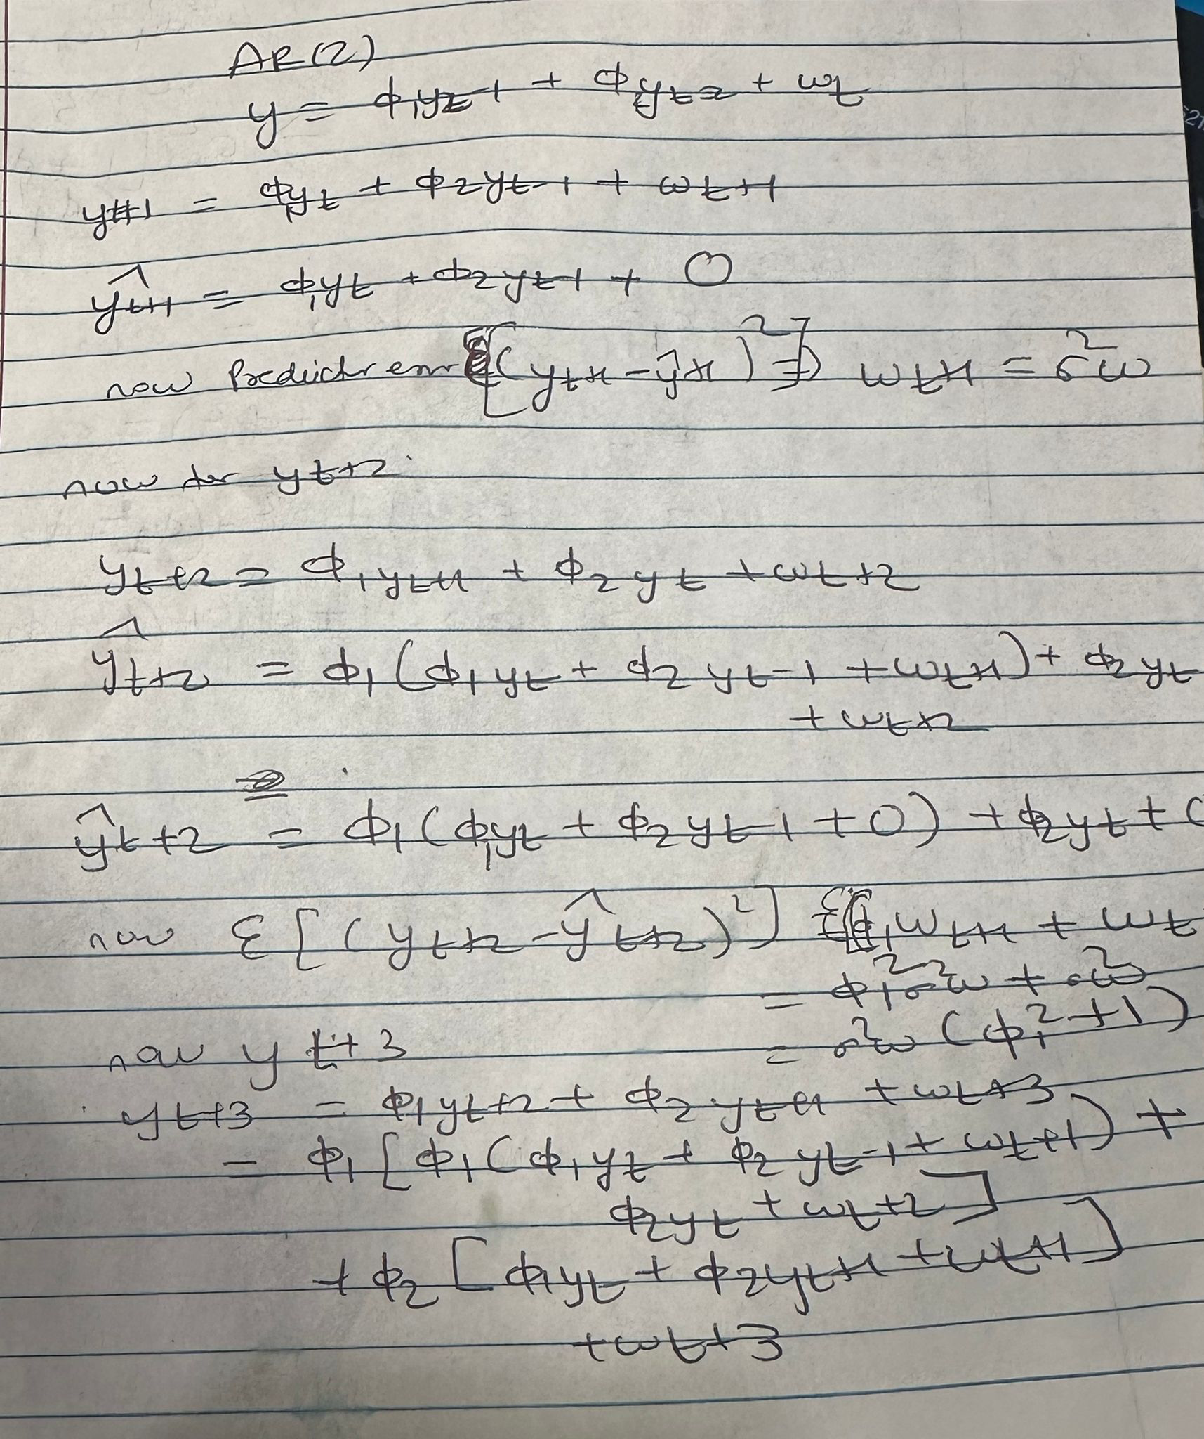

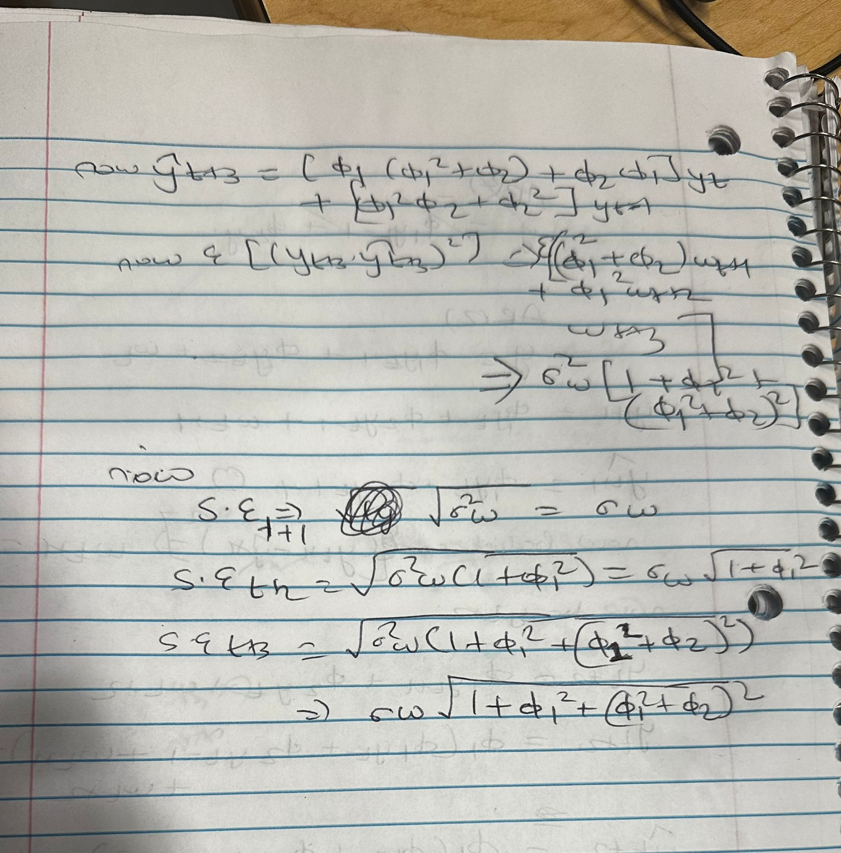

Q8)

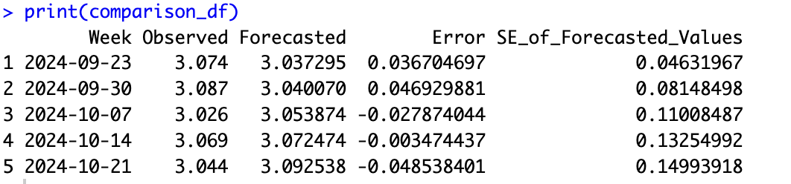

The model’s forecasts for the five weeks following the observed period are generally close to the actual gasoline prices, with only small errors in each week. The forecasted values show minor deviations from the observed prices, with errors ranging from -0.0485 to +0.0469. This indicates that the AR(2) model provides a reasonable prediction of the price trend, capturing the overall level accurately. Although there are slight over- and underestimations, the low magnitude of these errors suggests that the model effectively anticipates the weekly gasoline prices in the short term.

Q9)

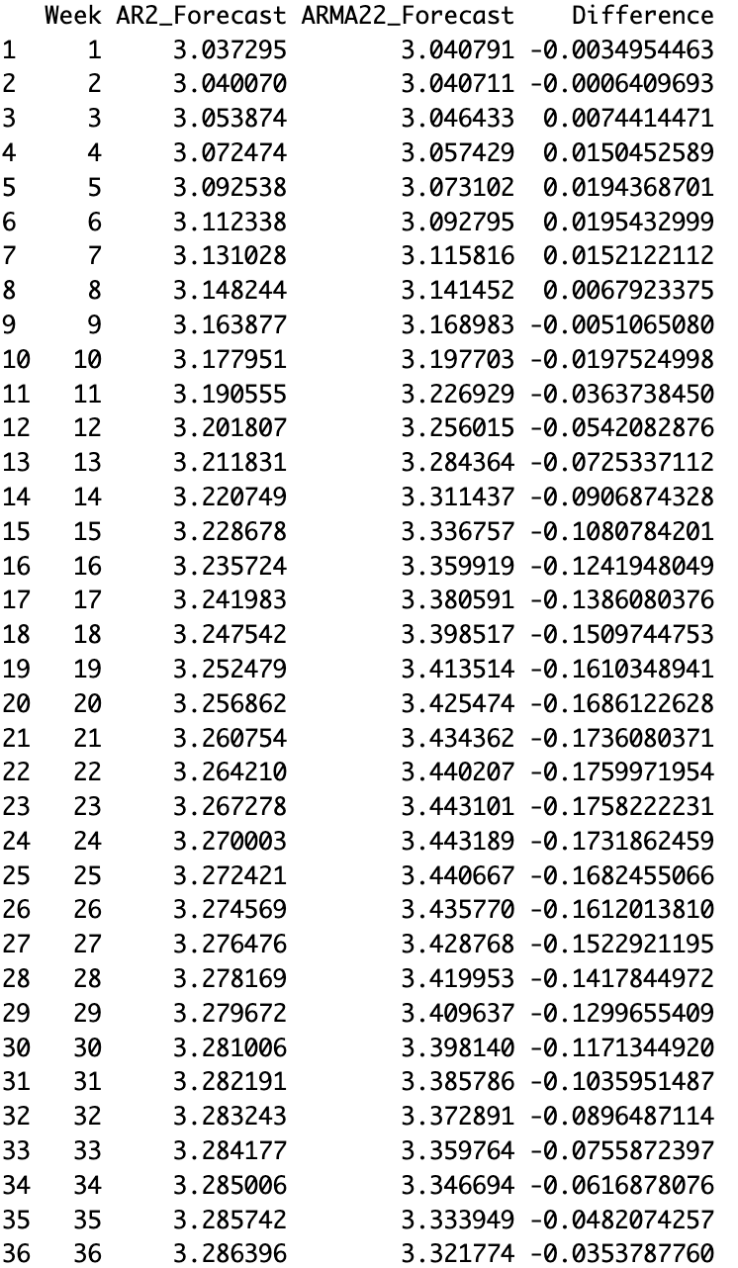

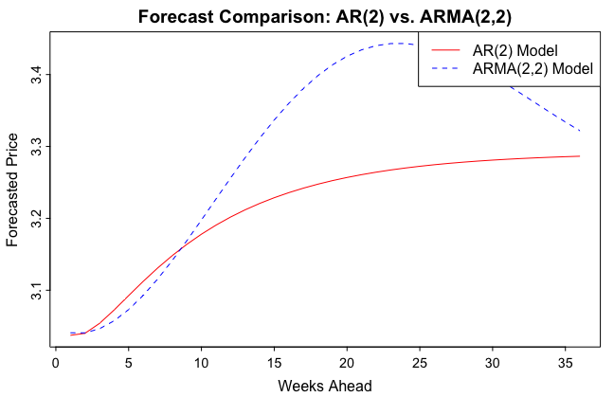

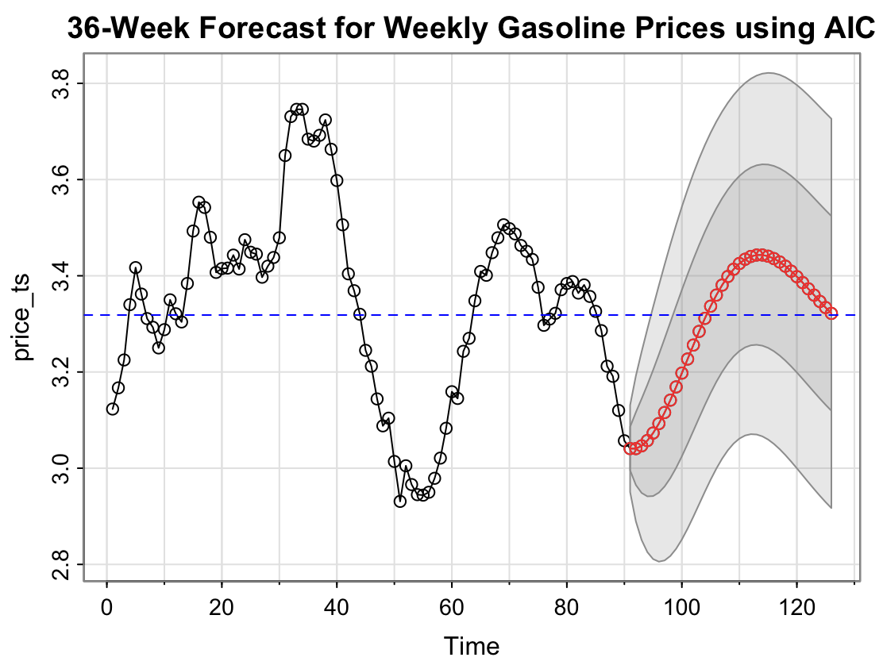

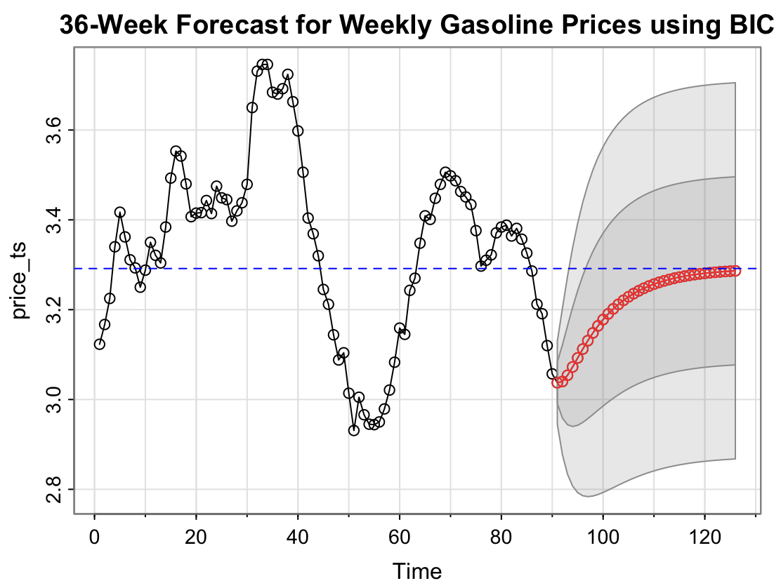

To address this question, I used the **AIC criterion** to identify an alternative model for the time series, selecting **ARMA(2,2)** as it offered a better fit compared to the AR(2) model. I then generated 36-week forecasts for both the AR(2) and ARMA(2,2) models to compare their predictive accuracy.

The forecasted values for each week show differences between the two models, with ARMA(2,2) capturing more fluctuations in the early weeks and showing a peak around the 15-week mark, whereas the AR(2) model follows a smoother trend. The upper intervals bound seem to be much wider for ARMA(2.2) and tighter bounds for AR(2).   
  
One more key observation is AR(2) does not show any trend and seem to mean-revert. While ARMA(2,2) seem to have a trend or drift for certain weeks and then mean-revert back.

The data table of forecasts and the graphical comparison illustrate these distinctions, where the ARMA(2,2) model provides slightly higher predictions initially but eventually converges towards the AR(2) forecasts.

Overall, the ARMA(2,2) model offers a marginally improved fit and captures some additional variability, but the overall trends from both models remain similar across the 36-week forecast period. Hence if we would want to work for having unrestricted forecasts we can have ARMA(2,2) with wider intervals and if we want much accurate and precise forecasts we should choose AR(2) with tighter interval bounds.

Q10)

Based on the analyses provided by the Augmented Dickey-Fuller (ADF) test, the Autocorrelation Function (ACF) and Partial Autocorrelation Function (PACF) plots, as well as the sequence plot of weekly gasoline prices, the time series appears to **be non-stationary**. The ADF test, which returned a Dickey-Fuller value of -1.622 and a high p-value of 0.7349, suggests a failure to reject the null hypothesis that the series has a unit root, indicating non-stationarity. This is supported by the ACF plot showing a slow decay in autocorrelations, persisting significantly across many lags, typical of non-stationary data.

The PACF plot indicates a significant spike at the first lag and cuts off thereafter, suggesting an autoregressive component of order 1, yet this does not confirm stationarity. The sequence plot visually corroborates these findings, displaying notable trends and variations in mean over time, which further points to the non-stationary nature of the data. To address this, differencing the series or applying transformations such as logging could help stabilize the variance and mean, after which re-evaluating stationarity.

